Network Functions

NET_CancelConnection() : Breaks an existing network connection.

Syntax
NET_CancelConnection( szRes[,lForce] ) ➔ lSuccess

Parameters
szRes local name.
lForce forcing disconnection. Optional parameter. By default, lForce is set to .F..

Returns
lSuccess .T. is the function succeeds; .F. otherwise.

Example
&& Disconnect network resource; force disconnection even if there are open
&& files or jobs on the connection.
? NET_CancelConnection( "K:",.T. )

See also
NET_CancelConnection()

NET_ConnectionDialog() : Presents a dialog box to establish a new network connection.

Syntax
NET_ConnectionDialog( [nType] ) ➔ lSuccess.

Parameters
nType 1 for disks resources (default); 2 for print resources.

Returns
lSuccess .T. if the function is successful; .F. otherwise.

Example
IF ( ! NET_ConnectionDialog() )
? "Error:",NET_LastError()
ENDIF
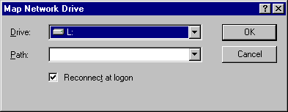
The Connection Dialog Box (Windows 95)
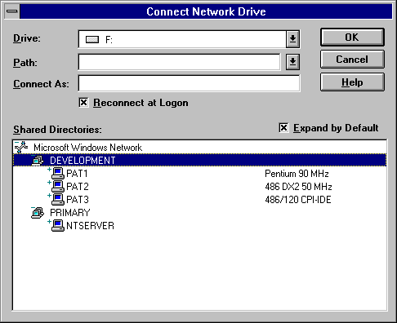
The Connection Dialog Box (Windows NT)

See also
NET_DisconnectDialog()

NET_DisconnectDialog() : Presents a dialog box to cancel a network connection.

Syntax
NET_DisconnectDialog() ➔ lSuccess

Parameters
None.

Returns
lSuccess .T. if the function is successful; .F. otherwise.

Example
NET_DisconnectDialog()
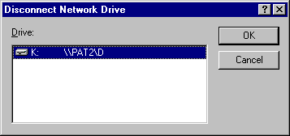
The Disconnect Dialog Box (Windows 95)
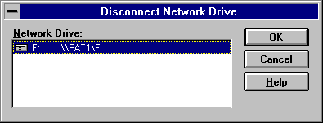
The Disconnect Dialog Box (Windows NT)

See also
NET_ConnectionDialog()

NET_EnumConnections() : Enumerates the network connections.

Syntax
NET_EnumConnections() ➔ szConnections

Parameters
None.

Returns
szConnections a tokenized string indicating all the connections. The string is formatted in such a way that the local resource is mentioned first, then a caret ("^") is placed, and finally the remote resource is mentioned. Multiple connections are separated by a ";". For example the following string denotes 2 connections :
F:^\\BEIPT15\F;G:^\\WALK2227\BUREAU, F: is mapped to \\BEIPT15\F and G: is mapped to \\WALK2227\BUREAU.

NET_EthernetAddress() : Obtains the Ethernet address of the network card.

Remark
The NetBIOS layer has to be active. The Ethernet address is formed out of 6 numbers.

Syntax
NET_EthernetAddress( [n] ) ➔ nAddress|szAddress

Parameters
n the address to obtain. Optional parameter. If passed n must be >= 1 and <= 6. When not passed, the full Ethernet Address is returned as a character string.

Returns
nAddress the desired address. –1 is returned when the Ethernet Address can’t be determined.
szAddress the full Ethernet address is returned when the n parameter is not passed to the function.

Example
LOCAL szAddress
szAddress = PADL( NUM_hexa( NET_EthernetAddress(1) ),3,"0" ) + "." + ;
PADL( NUM_hexa( NET_EthernetAddress(2) ),3,"0" ) + "." + ;
PADL( NUM_hexa( NET_EthernetAddress(3) ),3,"0" ) + "." + ;
PADL( NUM_hexa( NET_EthernetAddress(4) ),3,"0" ) + "." + ;
PADL( NUM_hexa( NET_EthernetAddress(5) ),3,"0" ) + "." + ;
PADL( NUM_hexa( NET_EthernetAddress(6) ),3,"0" ) + ;

NET_GetComputerName() : Retrieves the computer name of the current system.

Syntax
NET_GetComputerName() ➔ szComputer

Parameters
None.

Returns
szComputer computer name. This name is established at system startup, when it is initialized from the registry. If function was unsuccessful, it simply returns an empty string ("").

NET_GetHostName() : Returns the standard host name for the local machine.

Syntax
NET_GetHostName() ➔ szHost

Parameters
None.

Returns
szHost standard host name.

NET_GetUserName() : Returns the user name attached to the local machine.

Remark
The function can be very useful for logon processes.

Syntax
NET_GetUserName() ➔ szUser

Parameters
None.

Returns
szUser user name.

Example
? NET_GetUsername() && "Pat Boens"

NET_InternetTime() : Returns the Atomic clock date/time with 1sec accuracy.

Remark
The function can be very useful for synchronizing machines of a network.

Syntax
NET_InternetTime( [szHost] ) ➔ iUTC

Parameters
szHost optional host. By default, the internal host used by FOCUS.FLL is "time.nrc.ca". The following hosts implement Time protocol on the Internet:

time-a.nist.gov
time-b.nist.gov
time-a.timefreq.bldrdoc.gov
time-b.timefreq.bldrdoc.gov
time-c.timefreq.bldrdoc.gov
utcnist.Colorado.edu
time.nist.gov
time-nw.nist.gov
nist1.datum.com
nist.dc.glassey.com
nist.ny.glassey.com
nist.sj.glassey.com
nist1.aol-ca.truetime.com
nist1.aol-va.truetime.com

Returns
iUTC UTC time as integer.

Example
? TIM_CTime( NET_InternetTime( "time-nw.nist.gov" ) ) && Sun Mar 10 20:31:23 2002

NET_LastError() : Last error encountered in NET functions.

Syntax
NET_LastError() ➔ szLastError

Parameters
None.

Returns
szLastError last error that occurred while using the NET_*() functions.

Example
nEthernetID = NET_EthernetAddress(1)
? NET_LastError() && "The operation completed successfully."
nEthernetID = NET_EthernetAddress(-1)
? NET_LastError() && "Invalid parameter"

NET_LastVersion() : Returns the file stamp of NET functions.

Remark
This function helps the developer identifying the last version of a set of functions. Sometimes the global version information of FOCUS.FLL (MIS_major() and MIS_minor()) does not help tracking down the changes in a project. Starting with version 6.0 of FOCUS.FLL, each source file has now an internal date and time stamp.

Syntax
NET_LastVersion() ➔ szLastVersion

Parameters
None.

Returns
szLastVersion string identifying the last version of the functions set. The string is similar to "C:\Focus\5.0\NET.C-Mon Oct 19 15:55:22 1998".

NET_level() : Sets up the user level.

Syntax
NET_level( nLevel ) ➔ nOldLevel

Parameters
nLevel user level.

Returns
nOldLevel previous user level.

NET_max() : Maximum number of software users that can log in simultaneously.

Syntax
NET_max( <nUsers> ) ➔ nOldUsers

Parameters
nUsers number of users that can log simultaneously into your application.

Returns
nOldUsers previous number of users.

NET_mode() :?????????

Special
Not ready yet.

Syntax
NET_mode( nMode ) ➔ nOldMode

Parameters
nMode ????????

Returns
nOldMode ???????.

NET_proc() : Customizes the command to be executed by dedicated network timer.

Syntax
NET_proc( <cCommand> ) ➔ .T.

Parameters
cCommand FoxPro command.

Returns
.T. the function always returns .T..

NET_SetComputerName() : Sets the computer name to be used the next time the system is restarted.

Syntax
NET_SetComputerName( cName ) ➔ lSuccess

Parameters
cName computer name.
Windows 95 : If this string contains one or more characters that are outside the standard character set, those characters are coerced into standard characters.
Windows NT : If this string contains one or more characters that are outside the standard character set, NET_SetComputerName() returns .F.. It does not coerce the characters outside the standard set.
The standard character set includes letters, numbers, and the following symbols : ! @ # $ % ^ & ' ) ( . - _ { } ~ .

Returns
lSuccess .T.. if function was successful, .F. if not.

Example
OldName = NET_GetComputerName()
? NET_SetComputerName( "PAT78" )
? NET_SetComputerName( OldName )
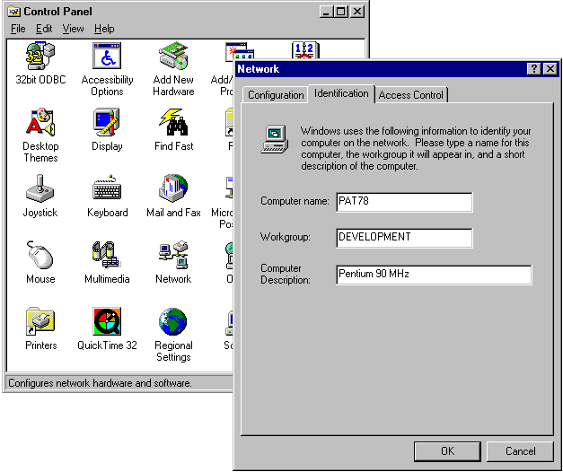
After changing the Computer Name (Windows 95)

NET_setnet() : Must the network be setting up.

Syntax
NET_setnet( <lStatus> ) ➔ lOldStatus

Parameters
lStatus .T. indicates that FOCUS should take care of network settings; .F. otherwise.

Returns
lOldStatus previous status of the network flag.

NET_timset() : Sets a timer dedicated to network attention.

Syntax
NET_timset( <nTimeInterval> ) ➔ nNetTimer

Parameters
nTimeInterval time interval in milliseconds.

Returns
nNetTimer time identifier.

NET_timkil() : Kills the dedicated network timer.

Syntax
NET_timkil( <nNetTimer> ) ➔ .T.

Parameters
nNetTimer timer identifier.

Returns
.T. the function always returns .T..

NET_timkil() : Kills the dedicated network timer.NET_userno() : User number.

Syntax
NET_userno( <nUserNo> ) ➔ nOldUserNo

Parameters
nUserNo most recently logged user number.

Returns
nOldUserNo previous most recently logged user number.

